Do we have to choose?

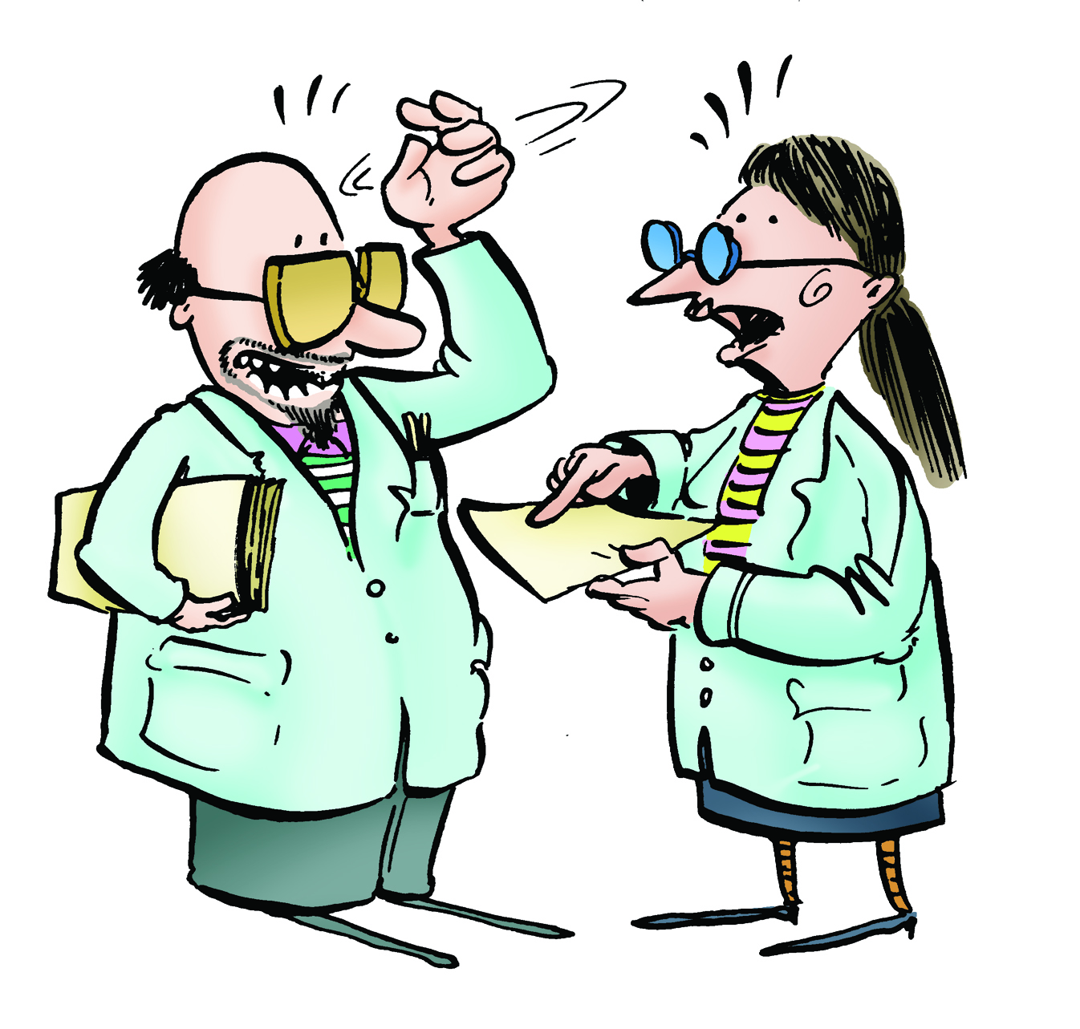

Key Aims of Session:

To show that science and religion are interested in different kinds of questions

National Curriculum Links

The non-statutory RE Framework 2013
Key Stage 2 (Primary)
Pupils discuss different perspectives on questions about the beginnings of life on Earth, so that they can describe different ways science and religions treat questions of origins

Learning objectives:

To understand how different answers may work well together if they are different types of explanations.

Differentiated outcomes:

ALL:
- Identify types of questions.
- Understand that more than one explanation may be right at the same time

MOST:
- Understand contradictory claims

Lesson in context/prior learning:

- Scientific and religious enquiries are usually focussed on different kinds of questions.
- Science explains how nature works. Scientific ideas can be tested by gathering observable evidence and by doing experiments. Scientific enquiry is a robust form of enquiry but it cannot tackle every kind of question.
- Religion addresses questions about ultimate purpose. Religious creation stories explain that God created the universe.
- Religious ideas are supported by evidence and reasons that may be subjective, personal and tentative. One person may see the beauty of the universe as a reason to believe in God while another does not

Resources:
- Detective Sheet 3: Tools of Enquiry
- Detective Sheet 4: Dancing Raisins
  - Raisins
  - Lemonade
  - Glass
- Video: “Science tells you ‘how’ and religion tells you ‘why” http://www.faradayschools.com/primary/different-types-of-explanation/

Session Plan:
(What the children (and teacher!) need to know before they start this lesson)
Element | Purpose | Timing | Summary
(e.g, learning hook, starter, plenary, investigation) | (why are you doing this –what should the children get out of it) | (How long will this bit take?) | What should the teacher/children do?
Starter | Explain a ‘Why?’ question can often be answered in several ways – and these different answers may work well together if they are different types of explanation. | 5 minutes | Hold a cup of hot chocolate (or imagine you are holding one) and ask the students why the hot chocolate is hot. Allow various answers such as:  - The milk was heated in a microwave  - I like a warm drink on a cold day  - The milk was heated in a saucepan on an electric ring  - My brother made it and he always makes it extra hot  - Heat transferred from the electric ring into the saucepan and then into the milk  Explain that more than one explanation be right at the same time. Ask if any of the claims contradictory (meaning that if this claim is true then another claim can’t be true).  Identify that (a) “The milk was heated in a microwave oven” seems to contradict (c) “The milk was heated in a saucepan on an electric ring” and also (e) Heat transferred from the electric ring into the saucepan and then into the milk
 | To allow children to identify types of questions and if some can fall in to more than one category | 15 minutes | Give out Detective Sheet 3: Tools of Enquiry. Students should discuss the talking points in pairs and then as a class write down the highlights of their discussion
 | To show how different answers to the same why question can work together | 5 minutes | Ask the students, “Why did the Titanic sink?”  Explain that One answer is, “because its captain, Captain Smith refused to listen to warnings by other ships that there were icebergs in that area and also because the shipbuilders had used substandard rivets (nails) along the seams of some of the panels.”  Another answer is, “because the ship was travelling fast when it struck the iceberg and the impact was enough to snap some of the rivets and rip the Titanic apart.”  Explain how these two answers can work together because one answer tells you “why – for what reason?” and the other tells you, “Why, in what manner”.
Video | To see scientists who can | 10 minutes | Watch a video where two scientists explain how science and religion answer different questions
Investigation and writing | To observe and explain an experiment | 15 minutes | Give out Detective Sheet 4: Raisin Ballet. Teacher should create the scientific experiment of raisins in a glass of lemonade for the pupils to draw on observations to explain what is happening.  Identify one answer to the why answer is because someone wanted to see what would happen. Another answer is their scientific observation. Can they both be right?  Pupils are then asked to think about the purpose of a Creation story.

Detective Sheet 3: Tools of Enquiry
1) The question, “When was the battle of Hastings?” is a history question. What about the questions below, what kinds of questions are they? Mark each one with the appropriate letter to show your idea of the kind of question it is. Be ready to explain your choices as opinions can differ!
Literacy = L, History = H, Religion=R, Science =S, Geography = G
- Did Harry Potter use magic on the Dursleys?  - What makes a good government?  - Why did the War of the Roses happen?  - Why is Pandora’s box important in Greek mythology?  - How deep is the deepest ocean?  - What is the most interesting book?  - Did King Alfred really burn some cakes?  - Are happy story endings better than sad ones?  - What is the carbon 14 dating method?  - Which religions have Adam and Eve in their Creation story?  - Where is the north pole?  - Why are arches important in architecture?  - How many lines does a sonnet have? | - Is trial by jury the fairest way to judge someone?  - Why do four-legged tables sometimes wobble?  - What causes meteor showers?  - The Khanda is a symbol in Sikhism. What does this symbol represent?  - Why is the sky dark at night?  - Who is Jesus, according to Christians?  - Do world leaders have any friends?  - What do Aboriginal Australians say was the role of the Rainbow Snake?  - What is a tectonic plate?  - How can we measure the speed of coastal erosion?  - How are planets different from stars?  - Why did women authors write under male pseudonyms  - Why do we have seasons?

Answers:
Worksheet Sorting questions
Many of the questions here (and in life) are ambiguous and can be fitted into other categories depending on how they are interpreted. Accept other categorisations if pupils can give a good explanation for their choices.
Literature
Why did women authors write under male pseudonyms
Are happy story endings better than sad ones?
Why didn’t Harry Potter use his magic powers to take revenge on the Dursleys?
How many lines does a sonnet have?
What is the world’s best book?
History (and politics)
What makes a good government?
Why did the War of the Roses happen?
Do world leaders have any friends?
Is trial by jury the best way to judge someone?
Did King Alfred really burn some cakes?
Science (and engineering)
Why are arches important in architecture? [science and/or history]
Why do four legged tables sometimes wobble?
How are planets different from stars?
Why do we have seasons?
What causes meteor showers?
Why is the sky dark at night?
Geography
What is a tectonic plate?
Where is the north pole?
How deep is the deepest ocean?
How can we measure the speed of coastal erosion?
Religious questions
Which religions have Adam and Eve in their Creation story?
What was the role of the Rainbow Snake in the religious stories of Aboriginal Australians?
Why is Pandora’s box important in Greek mythology?
The Khanda is a symbol in Sikhism. What does this symbol represent?
Who is Jesus, according to Christians?

Detective Sheet 4: Dancing Raisins
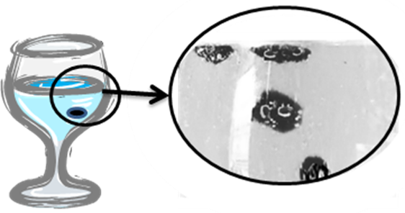 | When raisins are dropped into a glass of lemonade they fall to the bottom and then, mysteriously, they rise. Then they fall, then rise then fall...

What’s going on?
- What is carrying the raisins up to the surface? (look at the picture).
- What happens when the raisins get to the top and why?
- What do the raisins do then?
- So putting this all together, why do the raisins go up and down?

Explanations
- The explanation you’ve just given is a scientific explanation. It explains what causes the raisins to go up and down. When you look at Creation stories, you are seeing an explanation written by people thousands of years ago. If you look at it as a scientific explanation, you will see that it is very puzzling indeed. But it is not for scientific reasons that it is important to religious people. So why is it important to religious people?
I think the story of Creation is important for religious people because ...

Answers:

Detective Sheet 3: Dancing Raisins
The raisins are rising because air bubbles from the lemonade gather on the raisins. That lifts them up to the surface but there, the bubbles pop. The raisin flips over, because it has bubbles on its underside. Those bubbles pop and the raisin falls.

