
Unit 3: Are we nothing but the parts we
are made of?

Lesson 2: Pupil Worksheet 1

Why Paint?

What can be the purposes of putting paint onto canvas or paper? Who would say what?
Can you match these four people to the four purposes by drawing lines?

To dab and daub paint

To make something that looks like (represents) the world we live in?

To put our own meaning into (interpret) what we see?

To make someone’s home look nice
LANDSCAPE ARTIST

INTERIOR DESIGNER

YOUNG TODDLER

MODERN ABSTRACT ARTIST

Lucie’s two pictures

Lucie is a toddler who is just enjoying splashing paint onto big pieces of paper at her nursery. She loves to see the bright colours and to know that she is making them herself with her brush or fingers.

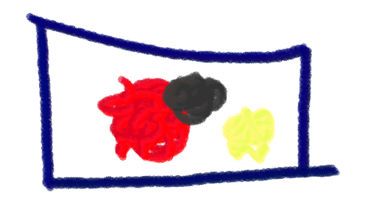

Now Lucie has a paintbrush in her hand and she says, ‘This is my house’. To you it just looks like blobs of red and black paint.

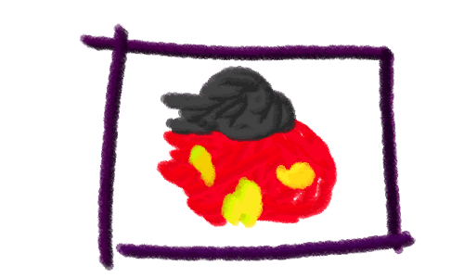

Lucie’s two pictures don’t look very different from each other.

What makes them different? Use the word purpose if you can.

Write your answer here

Which one is made of parts without giving us a ‘whole’ picture to see?

Write your answer here

Why does Lucie saying, ‘This is my house’, make us see a whole picture?

Write your answer here

