
Unit 3: Are we nothing but the parts we
are made of?

Lesson 1: Pupil Worksheet 2

The sum of its parts

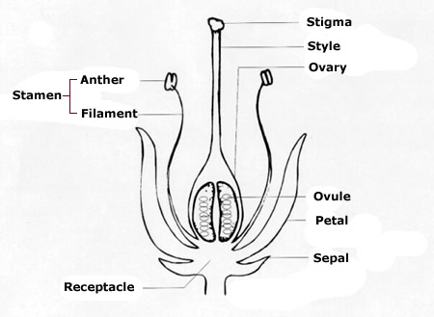
Here is a diagram of a flowering plant. We’ll call her Little Weed.

I guess you know what all those different labelled parts do exactly? How they help Little Weed to live, reproduce and stay healthy?

If you were in the garden with Little Weed, how could you find out more about the stamens (without causing harm to the plant)?

Write your answer in the box

How would this help you to know more about the whole plant?

Unit 2: Are we nothing but the parts we
are made of?

Lesson 1: Pupil Worksheet 2

The sum of its parts

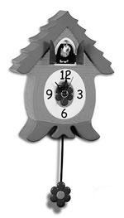
Do you like cuckoo clocks? You’ve always wanted one? The way those pendulums swing, and the weights go up and down, and the little cuckoo comes flying out of his door to shout cuckoo every hour! Who wants a boring old battery operated clock? Well, those cuckoo clocks are built with great precision which means all the parts have to be working absolutely correctly, or the whole thing goes wrong. If one part is broken or faulty the clockmaker replaces it with another part.

The clockmaker might say,

A CLOCK IS THE SUM OF ITS PARTS

What would he mean? Well, when you do a ‘sum’ you add up. The clockmaker means that you have to add all the parts of the clock together to get the whole ‘answer’ or working cuckoo clock.

If you said, A BICYCLE IS THE SUM OF ITS PARTS what would you mean?

Write your answer here.

