
Unit 3: Are we nothing but the parts we
are made of?

Lesson 1: Pupil Resource 1

Mixed messages

Would you like some handlebars, pedals, gears, a frame, tyres and wheels for your birthday?

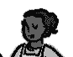

No thanks, I’d rather have a bike.

