
Unit 9: Are you an Alien?

Lesson 4: Pupil Resource 1

The Life of The Buddha

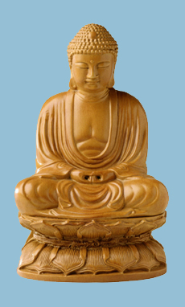
The person we call The Buddha was born over two and a half thousand years ago in India, near the modern border with Nepal. In those times India was divided into many small kingdoms. His father ruled one of the kingdoms.

Buddha was then called Siddhartha Gautama, and he was brought up to have a life of luxury in his father’s beautiful and magnificent palace.

From the age of eight, Gautama was taught at the palace by Hindu priests and other great teachers, and he always listened solemnly. When he was older he had to learn the arts of war. This was because if he became king he would have to lead his people into battle if there was war against neighbouring kingdoms. He was also taken hunting on horseback. But Gautama disliked all killing, whether of humans or animals. He thought it was wrong to take the lives of other creatures, especially for sport.

His father noticed his son’s gentle and holy ways and feared that Gautama might be led away from his duties as future king by the men of religion. He tried to spoil Gautama by giving him everything a young man could want. He had three new palaces built specially for him, with food, drink, dancing girls and all the luxuries you could think of.

One day however, Gautama drove into town in his chariot. Then he saw what life was like outside the palace walls. He saw an old, helpless man, someone else with a terrible illness, and a body of someone who had died being taken away to be cremated. He saw many poor people.

He realised his own life of pleasure was not normal, and that one day he too would become old and die, like everyone else. He found this very hard to accept, and the idea of it made him suffer.

Gautama decided to leave the palace and go to live in the forest as a holy man. He wore a simple white robe and took only a begging bowl. He wanted to find out the truth about life and death. Of course his father was very upset.

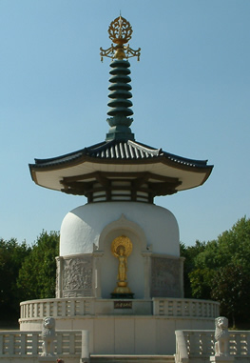
In the forest, Gautama at first tried going without food, as some Hindu monks did, to see if it would make his thoughts clearer, but it didn’t - it just made him ill.
So he sat beneath a banyan tree and meditated, with the idea of controlling his mind and using it to obtain spiritual knowledge.

After six weeks, he is said to have achieved Enlightenment. All living things want to live long lives, he said, but they don’t want to suffer. Suffering is caused by desire, which prevents contentment and generosity. By wanting things for ourselves all the time we create our own suffering and that of others.

He worked out what he thought was the best way for humans of thinking and living and he wrote it all down. He became known as The Buddha, which means The Enlightened One. He said that everyone should speak, act and live in a kind and considerate way to all living things. He also said that people should meditate in order to control their thoughts.

People flocked to hear what Buddha had to say, and he became famous and well-loved by rich and poor people alike who listened carefully to his wise words. Even his own father came to hear him speak. Some people left their homes and travelled with him.

Buddha lived to be eighty. When he died, his followers started to call themselves Buddhists, after him.

Image Credits: Education Photos

