
4a: What does science have to say
about the beginning of the universe?

Lesson 2: Student Worksheet 1

Questions on How the Universe Evolved

Answer the following questions during the PowerPoint presentation on the sequence of creation. The number of the slide on which the answer appears is in brackets [] after the question

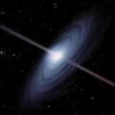
1. What is the name of the old fashioned theory that
was popular before the Big Bang was accepted? [2]
2. How old is the universe? [3]
3. What is the name of the satellite that produced the
image? [3]

4. Complete this sentence: red parts of the image are _______________ density regions, blue parts are ____________________ density regions. [3]
5. What is the name of the force that holds galaxies together into clusters? [4]
6. Complete this sentence: Clusters of galaxies are arranged into long thin ____________________ between which are large empty ____________ [5]
7. What is the significance of collisions between galaxies in the early universe? [6]
8. What is a Nebula? What takes place inside some nebulae? [8]
9. What are stars mostly made of? [10]
10. What is the name of the process which turns light elements into heavier ones inside a star? [10]
11. What three things to do with stars are important for life? [10]
12. What is a supernova? [11]
13. Supernova 1987a was important for what reason? [12]

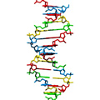
14. What are the two ways in which life may have started on Earth? [16]
15. The presence of which element in the atmosphere is a clue for life? [16]
16. What does the word helix mean? [17]
17. What chemicals link together to make proteins? [17]
18. The two things that can be found inside complex cells are ________________ and ________________ . [18]

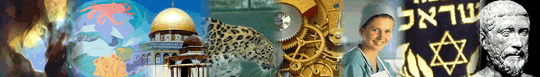

19. Who came up with the idea of genes? [19]
20. What types of plant were used in the first genetic experiments? [20]
- What is mutation? [20]



22. What was Darwin’s contribution to the theory of evolution? [20]
23. What is the most complex system known to science? [20]

