3a: [11-14] Early Influences 

Lesson 2: Student Resource Sheet 3

The Venus Tablet

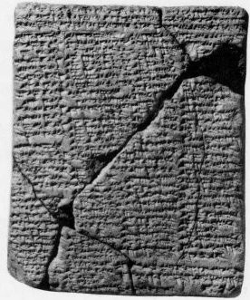
In month XI, 15th day, Venus disappeared in the west. Three days it stayed away, then on the 18th day it became visible in the east. Springs will open and Adad will bring his rain and Ea his floods. Messages of reconciliation will be sent from King to King.

This text was written around 1636 BC during the reign of King Amisaduqa of Babylon. It was inscribed with a stylus on a block of clay, and is known as the Venus Tablet of Amisaduqa. It is one of a series of ‘omen tablets’. Observations and interpretations of the rising and setting of planets were the basis on which predictions were made, usually concerning the well-being of the King and the country.

In this tablet, the planet under observation was Venus.

